Antonio Urdaneta

**Configuring Static VLANs on Cisco Switches**

Network Topology (Logical)

SWITCHPORT CONFIGRUATIONS

|  |  |  |  |  |  |  |
| --- | --- | --- | --- | --- | --- | --- |
| Equipment | Address | MASK | Switchport | Mode | VLAN | Switch |
|  |  |  |  |  |  |  |
| PC11 | 192.168.21.11 | 255.255.255.0 | Fa0/1 | Access | 10 | B |
| PC12 | 192.168.21.12 | 255.255.255.0 | Fa0/2 | Access | 10 | B |
| PC13 | 192.168.21.13 | 255.255.255.0 | Fa0/3 | Access | 20 | B |
| PC14 | 192.168.21.14 | 255.255.255.0 | Fa0/4 | Access | 20 | B |
|  |  |  |  |  |  |  |
| PC15 | 192.168.21.15 | 255.255.255.0 | Fa0/1 | Access | 10 | A |
| PC16 | 192.168.21.16 | 255.255.255.0 | Fa0/2 | Access | 10 | A |
| PC17 | 192.168.21.17 | 255.255.255.0 | Fa0/3 | Access | 20 | A |
| PC18 | 192.168.21.18 | 255.255.255.0 | Fa0/4 | Access | 20 | A |

LAN-SWITCH CONFIGURATIONS

|  |  |  |  |
| --- | --- | --- | --- |
| Display/ Hostname | Trunk Port | Access Ports | Encapsulation Type |
|  |  |  |  |
| LAN-SwitchA | Fa0/24 | Fa0/1-4 | IEEE 802.1Q |
| LAN-SwitchB | Fa0/24 | Fa0/1-4 | IEEE 802.1Q |

**Commands**

**Successful Ping from PC to PC**

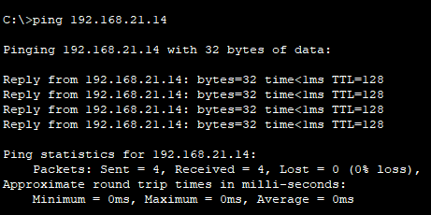

**Unsuccessful Ping from PC to PC (between VLANs)**

**#show ip interface**

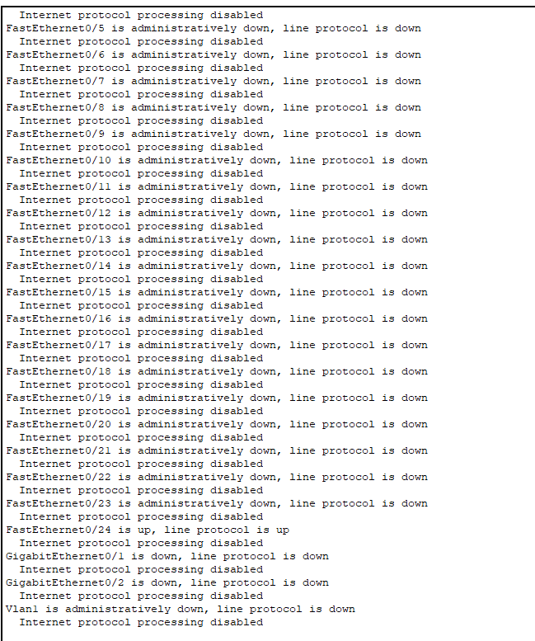

**#show vlan**

**LAN-Switch A**

**LAN-Switch B**

